



**Product_NAME Integration Guide v1.0**

Security Orchestration, Automation and Response Platform

Licensed Materials – Property of IBM

© Copyright IBM Corp. 2010, 2019.  All Rights Reserved.

US Government Users Restricted Rights: Use, duplication or disclosure restricted by GSA ADP Schedule Contract with IBM Corp.

Resilient Security Orchestration, Automation and Response (SOAR) Platform  
<name_of_app> Integration Guide

|  |  |  |
| --- | --- | --- |
| Version | Publication | Notes |
| 1.0 | May 2019 | Initial release. |

Table of Contents

1. About this template (delete when done) 5

2. Overview 6

2.1. Use cases 6

2.2. Terminology 6

2.3. Feature 1 6

2.4. Feature 2 6

3. Installation 7

4. Package contents 7

5. Custom layout 8

6. <Function Name> description 8

7. <Function Name> description 9

8. Configure <Product_Name> 9

9. Inform Resilient Users 10

# About this template (delete when done)

Use this template to create a User Guide for your Resilient function. It is designed to be used in conjunction with the Resilient *Integration Server Guide*. Examples are provided. This guide contains the following sections:

* **Overview**: Describe the purpose of the function package.
* **Installation**: List any special installation steps or requirements above and beyond those requirements listed in the *Integration Server Guide*.
* **Package contents**: List the functions and each component (workflow, rules, and so on).
* **Custom layout**: Only needed if you require the Resilient user to create custom fields or data tables. Provide a recommendation on where to place these components – whether a new or existing incident layout.
* **Function <name> description**: Provide a detailed description of how the function works with workflows, rules, fields, data tables and so on. Provide screenshots if you feel they will be helpful. If you have multiple functions in one package, create a section for each function.

When done and before making a PDF, change the title of your Word file in **File>Info> Advanced Properties**.

If writing a readme for the online community, make it short. Describe the purpose of the function package and point to your guide for details.

If you have a simple integration and you do not wish to have a Table of Contents, use the [Template for Resilient Functions User Guide](https://github.com/ibmresilient/resilient-reference/blob/master/developer_guides/Template%20for%20Resilient%20Functions%20User%20Guide.docx).

# Overview

***<Provide a high-level description of the function itself and its remote software or application. You may want to organize major features into subsections. The following text is an example>***

The McAfee ePO function contains the ability to apply a tag to a system managed in ePO from the Resilient platform.

This guide provides a description of the functions and components within the function package, any additional requirements, and a list of settings that need to be added to the Resilient Circuits app.config file.

## Use cases

***<Optionally, provide a list of use cases that the integration addresses.>***

This integration supports the following general use cases:

* Gather event data by UUID.
* Search for events by criteria.
* Search for events contained within a specific archive.
* Create incidents automatically.

## Terminology

***<Optionally, define any product-specific terms that users may not intuitively*** ***understand.>***

## Feature 1

***<Optionally, if there are number of features, you may want to describe each major feature in its own subsection. >***

## Feature 2

***<Optionally, if there are number of features, you may want to describe each major feature in its own subsection. >***

# Installation

You download the function package to a Resilient integration server, and from there you deploy the functions and components to a Resilient platform. These procedures are provided in the [Resilient Integration Server Guide (PDF)](https://github.com/ibmresilient/resilient-reference/blob/master/developer_guides/Integration%20Server%20Guide.pdf).

The functions included this package have the following requirements, which are above and beyond those listed in the *Resilient* *Integration Server Guide*.

* Resilient platform is version ***xx*** or later.
* <*is a new incident tab needed in the Layouts section of the Resilient platform to contain the custom fields and data tables?*>
* <*is there a special port that needs to be opened?*>

After installing the package, Resilient Circuits creates a new section, <*name of section*>, in the app.config file. You need to edit the following settings in that section.

***<Replace the following example with the section created for your function>***

[fn_microsoft_security_graph]

# Graph URL with version number  
microsoft_graph_url=https://graph.microsoft.com/v1.0/  
tenant_id=<Tenant directory id>  
client_id=<App client id>  
client_secret=<App client secret>

***<Provide details of each setting as necessary>***

# Package contents

The following table lists the functions included in the package, along with associated workflows and rules.

|  |  |  |
| --- | --- | --- |
| **Function** | **Workflow** | **Rule** |
| Function name | Workflow name | Rule name |
| Function name | Workflow name | Rule name |
| Workflow name | Rule name |

***<Provide a list of custom incident fields and data tables.>***

***<NOTE: Describe the function’s input fields in the Function <name> description section.>***

The package also requires that the following fields and data tables are created in the Resilient platform:

* Field name
* Field name
* Data table name
* Data table name

# Custom layout

***<Use this section to provide guidance on where the user should add any custom fields and data tables. You may wish to recommend a new incident tab, as shown in the following example. Delete this section if not applicable.>***

To use the functions, the Resilient playbook designer needs to create a new Incident tab containing the custom fields and data tables. The examples in this guide assume that the incident tab is named MITRE. For example:

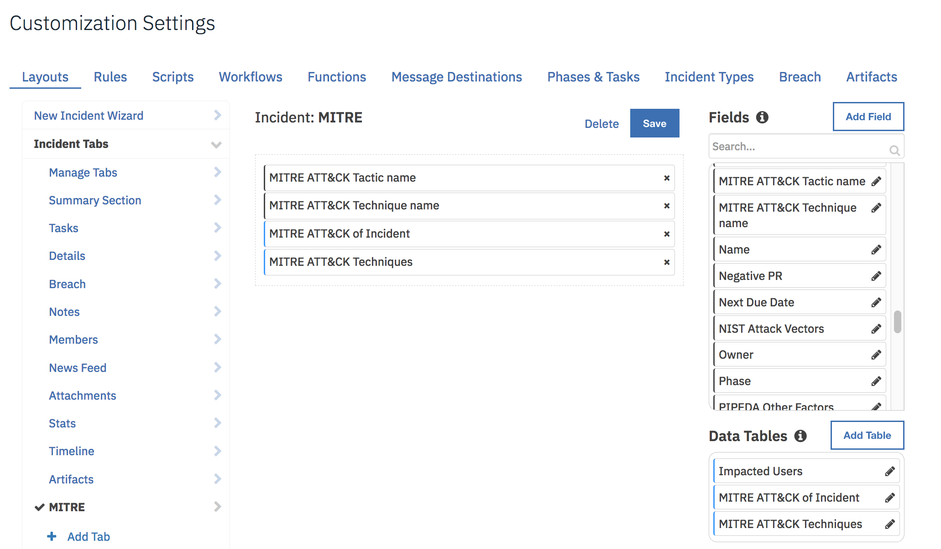

# <Function Name> description

***<Provide a detailed description of the function, its inputs, and pre-process and post-process scripts. Here is a simple example.>***

This function adds a new item to an existing QRadar reference set. It uses two input parameters:

* qradar_reference_set_name is the name of an existing reference set in QRadar
* qradar_reference_set_item_value is the value to be added.

The input is populated by the workflow, “Example of adding an item to QRadar reference set”.

The workflow, “Example of adding an item to QRadar reference set”, sets the function’s input fields:

* “qradar_reference_set_name” is mapped to “Sample Blocked IPs”
* qradar_reference_set_item_value is mapped to the artifact value, and then runs the function.

The workflow is initiated by the rule, “QRadar Add to Reference Set”.

The example rule, “QRadar Add to Reference Set”, is a menu item rule for an artifact. The user can select this action in the menu to initiate the workflow.

# <Function Name> description

***<Provide a detailed description of the function, its inputs, and pre-process and post-process scripts. Here is a more complex example>***

This function retrieves ATT&CK information on the given MITRE technique from the MITRE STIX TAXII server. To retrieve information on a MITRE technique from within an incident:

1. Open an incident and select the MITRE tab.
2. Edit the custom field, “MITRE ATT&CK Technique name” and enter a technique name, for example, “AppleScript”.
3. Click **Actions->Get MITRE technique information**.

This invokes the “Example of getting MITRE technique information” workflow, which calls the “MITRE Technique Information” function. The workflow uses the results to populate the “MITRE ATT&CK Techniques” data table. For example:

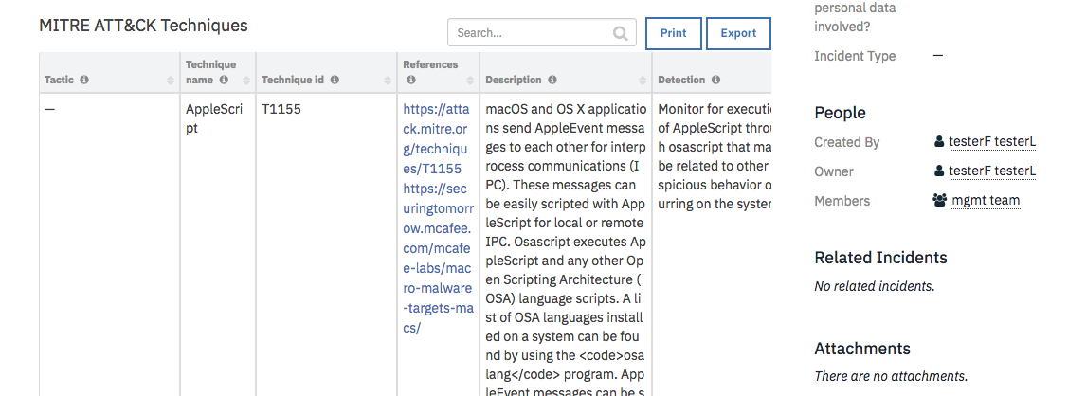

The technique ID can also be used to look up information on the technique.

# Configure <Product_Name>

***<If necessary, use this section to describe how to configure your security application to work with the integration. Delete this section if the user does not need to perform any configuration procedures on your product.>***

# Inform Resilient Users

***<Optionally, provide additional information so that Resilient users can get the maximum benefit of your integration.***

***The target audience for this guide is the Resilient playbook designer. These users configure the incident response aspect of the Resilient platform, including rules, functions, workflows, data tables, custom fields, and so on. Provide any helpful advice to help them get the maximum benefit of the integration in their environments.***

***The Resilient platform has another class of users, incident responders. These responders can be analysts, IT, and Support. With them in mind, provide any helpful advice about how to best use this integration in the context of an incident. For example, your integration may populate a data table which also allows a user to perform an action on your product directly from the data table.***

***To better understand these users, see the User Guide and Platform Playbook Designer Guide. You can find these documents in the Resilient platform’s Help/Contact menu, or online in the*** [***IBM Knowledge Center***](https://www.ibm.com/support/knowledgecenter/SSBRUQ)***.>***